
RAJALAKSHMI INSTITUTE OF TECHNOLOGY
(An Autonomous Institution, Affiliated to Anna University, Chennai)

DEPARTMENT OF CSE (ARTIFICIAL INTELLIGENCE AND MACHINE LEARNING)
ACADEMIC YEAR 2025 - 2026
SEMESTER IV
AL23421 - MACHINE LEARNING LABORATORY
MINI PROJECT REPORT

REGISTER NUMBER | 2117240030075
NAME | LOKESH R
PROJECT TITLE | Weather-Based Crop Recommendation System
DATE OF SUBMISSION
FACULTY IN-CHARGE

Signature of Faculty In-charge Signature of HoD

INTRODUCTION:
- Agriculture productivity depends heavily on weather conditions like rainfall and temperature .
- Machine Learning helps farmers choose the best crop for given conditions.
- This project uses:
- Decision Tree
- K-Nearest Neighbors (KNN)

Why important:
- Reduces crop failure
- Improves yield
- Supports smart farming
Aim:
- Recommend the most suitable crop based on weather conditions.

PROBLEM STATEMENT:
- “To develop a machine learning system that recommends suitable crops based on weather parameters like rainfall and temperature, and to compare Decision Tree and KNN model performance.”
GOAL:
• Predict best crop with high accuracy
• Compare:
- Decision Tree
- KNN
Expected Outcome:
- Best performing model
- Accurate crop recommendations

THEORETICAL BACKGROUND

1. Decision Tree Algorithm:
Entropy(S)= −∑^{n}_{i=1}p_{i}log₂p_{i}​
- Splits data based on features
- Uses entropy & information gain

2. KNN Algorithm:
d(x,y)=$√\sum_{i=1}^{1}{{(xi-yi)}^{2}}$
- Based on distance between data points
- Classifies using nearest neighbors

3.Literature Survey:
- Smart agriculture using ML (IEEE, Springer papers)
- Common algorithms:
  - Random Forest
  - SVM
  - Neural Networks

4.Justification:
- Decision Tree:
  - Easy to interpret
- KNN:
  - Simple and effective

ALGORITHM EXPLANATION WITH EXAMPLE
Sample Dataset:
Temp (°C) | Rainfall(mm) | Crop
30 | 200 | Rice
25 | 100 | Wheat

Working:
- Input:
  - Temperature
  - Rainfall
- Output:
  - Recommended Crop

Graphs:
- Rainfall vs Crop
- Temperature vs Crop
- KNN distance visualization

IMPLEMENTATION CODE AND DATASET USED

Category | Description / Example
Dataset Name | Crop Recommendation Dataset
Domain | Agriculture
Objective | Classification
Data Source | Kaggle
Number of Samples | ~2200
Data Type | Tabular
Instance Description | One record = soil + weather
Features (Inputs) | Temp, Rainfall, Humidity
Feature Types | Numerical
Target Variable | Crop Type
Number of Classes | Multiple crops
License | Open
Version | v1

- Python code:
import pandas as pd
from sklearn.model_selection import train_test_split
from sklearn.tree import DecisionTreeClassifier
from sklearn.neighbors import KNeighborsClassifier
from sklearn.metrics import accuracy_score
data = pd.read_csv("crop.csv")
X = data[['temperature','rainfall']]
y = data['crop']
X_train, X_test, y_train, y_test = train_test_split(X,y,test_size=0.2)
dt = DecisionTreeClassifier()
dt.fit(X_train,y_train)
dt_pred = dt.predict(X_test)
knn = KNeighborsClassifier(n_neighbors=5)
knn.fit(X_train,y_train)
knn_pred = knn.predict(X_test)
print("DT Accuracy:", accuracy_score(y_test,dt_pred))
print("KNN Accuracy:", accuracy_score(y_test,knn_pred))
OUTPUT:
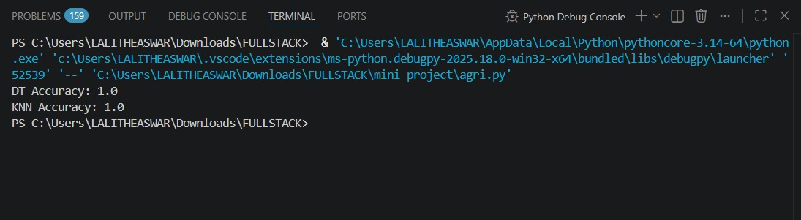
RESULTS AND FUTURE ENHANCEMENT
Factor | Decision Tree | KNN
Accuracy | High | Moderate
Speed | Fast | Slow
Interpertability | Easy | Difficult

Impact Analysis:
- Rainfall:
  - High → Rice 🌾
  - Low → Wheat 🌱
- Temperature:
  - High → Maize 🌽
  - Moderate → Pulses

Recommendation Correctness:
- Based on real dataset validation
- Higher accuracy = better recommendation
- Decision Tree performed better overall

Future Enhancements:
- Add soil nutrients data
- Use Deep Learning
- Real-time weather API integration

Git Hub Link of the project along with the report

REFERENCES:
- Kaggle Crop Dataset
- Scikit-learn Docs
- IEEE Smart Agriculture Papers
- Springer ML Agriculture Research
- Agricultural Data Science Blogs

